MACHINE LEARNING-BASED PREDICTIVE ANALYTICS FOR EARLY DETECTION OF DIABETES
A PROJECT REPORT
Submitted by
ANBU SELVAN M
24CSR021
BHARANIDHARAN D
24CSR037
BHAVANA R
24CSR040

in partial fulfilment of the requirements for
the award of the degree
of
BACHELOR OF ENGINEERING
IN
COMPUTER SCIENCE AND ENGINEERING

DEPARTMENT OF COMPUTER SCIENCE AND ENGINEERING

(Autonomous)
PERUNDURAI ERODE – 638 060
MAY 2026
DEPARTMENT OF COMPUTER SCIENCE AND ENGINEERING
KONGU ENGINEERING COLLEGE
(Autonomous)
PERUNDURAI, ERODE -638060
MAY 2026

BONAFIDE CERTIFICATE

This is to certify that the Project Report entitled MACHINE LEARNING-BASED PREDICTIVE ANALYTICS FOR EARLY DETECTION OF DIABETES is the Bonafide record of project work done by ANBU SELVAN M (Register no: 24CSR021), BHARANIDHARAN D (Register no: 24CSR037), BHAVANA R (Register no: 24CSR040) in partial fulfilment of the requirements for the award of the Degree of Bachelor of Engineering in Computer Science and Engineering of Anna University, Chennai during the year 2025 - 2026.

SUPERVISOR HEAD OF THE DEPARTMENT

Date: (Signature with seal)

Submitted for the end semester viva voce examination held on ____________________

INTERNAL EXAMINER EXTERNAL EXAMINER

DEPARTMENT OF COMPUTER SCIENCE AND ENGINEERING KONGU ENGINEERING COLLEGE
(Autonomous)
PERUNDURAI, ERODE-638060
MAY 2026

DECLARATION

We affirm that Project Report titled MACHINE LEARNING-BASED PREDICTIVE ANALYTICS FOR EARLY DETECTION OF DIABETES being submitted in partial fulfilment of the requirements for the award of Degree of Bachelor of Engineering is the original work carried out by us. It has not formed part of any other project report or dissertation on the basis of which a degree or award was conferred on an earlier occasion on this or any other candidate.

Date: ANBU SELVAN M
(24CSR021)

BHARANIDHARAN D
(24CSR037)

BHAVANA R

(24CSR040)

I certify that the declaration made by the above candidates are true to the best of my knowledge.

Date: Name & Signature of the Supervisor with seal

ABSTRACT

Diabetes mellitus is a chronic metabolic disorder characterised by elevated blood glucose levels and is one of the fastest-growing public health challenges globally. According to the World Health Organization (WHO), approximately 830 million people are currently living with diabetes, and the prevalence among adults has risen from 4.7% in 1980 to nearly 8.5% in recent years. The disease is responsible for nearly 1.5 million deaths annually and is a leading cause of serious complications including cardiovascular disease, chronic kidney failure, and stroke. The rapid escalation in diabetes cases underscores the critical need for accurate and early detection systems that can support preventive healthcare.
This project proposes a Machine Learning-Based Diabetes Prediction System trained on a dataset of 100,000 patient records containing eight clinical and demographic features — gender, age, hypertension, heart disease, smoking history, Body Mass Index (BMI), HbA1c level, and blood glucose level. The dataset exhibited a significant class imbalance of 8.5% diabetic versus 91.5% non-diabetic records, which was addressed using the Synthetic Minority Over-sampling Technique (SMOTE) applied exclusively on the training partition following a stratified 80/20 train-test split.
Five supervised machine learning models were trained and compared — Logistic Regression, Random Forest, XGBoost, Soft Voting Ensemble, and Stacking Ensemble. All models were evaluated using ROC-AUC, F1-score, Precision, and Recall as primary metrics. XGBoost achieved the best performance with a test-set ROC-AUC of 0.9757 and F1-score of 0.8003 and was selected as the final model. To ensure clinical interpretability, SHAP (SHapley Additive exPlanations) analysis was performed on the final XGBoost model. This project contributes to United Nations Sustainable Development Goal 3 — Good Health and Well-Being — by supporting scalable and technology-driven early diabetes detection.

ACKNOWLEDGEMENT

We express our sincere thanks and gratitude to Thiru. E. R. K. KRISHNAN, M.Com., our beloved Correspondent, and all other philanthropic trust members of Kongu Vellalar Institute of Technology Trust who have always encouraged us in academic and co-curricular activities.

We are extremely thankful with no words of a formal nature to the dynamic Principal Dr. R. PARAMESHWARAN, M.E., Ph.D., for providing the necessary facilities to complete our work.

We would like to express our sincere gratitude to our respected Senior Professor and Head of the Department Dr. S. MALLIGA, M.E., Ph.D., for providing the necessary facilities.

We extend our thanks to our Project Coordinator Ms. P. SANTHIYA, B.E., M,E., (Ph.D)., Assistant Professor [SRG], Computer Science and Engineering, for her encouragement and valuable advice that made us carry out the project work successfully.

We extend our gratitude to our Supervisor Dr. N. SHANTHI, M.E., Ph.D., Senior Professor of Computer Science and Engineering, for her valuable ideas and suggestions, which have been very helpful in the project. We are grateful to all the faculty members of the Computer Science and Engineering Department, for their support.

TABLE OF CONTENTS
CHAPTER No. | TITLE | PAGE No.
 | ABSTRACT | iv
 | LIST OF TABLES | ix
 | LIST OF FIGURES | x
 | LIST OF ABBREVIATIONS | xi
1 | INTRODUCTION | 1
 | 1.1 EXISTING SYSTEM | 2
 | 1.2 OBJECTIVE | 3
 | 1.3 SCOPE | 4
2 | LITERATURE SURVEY | 5
 | 2.1 REVIEW OF LITERATURE | 5
 | 2.2 SUMMARY | 8
3 | REQUIREMENTS | 11
 | 3.1 HARDWARE REQUIREMENTS | 11
 | 3.2 SOFTWARE REQUIREMENTS | 11
 | 3.3 LIBRARIES AND FRAMEWORK | 11
 | 3.3.1 Data Handling | 11
 | 3.3.2 Visualization | 12
 | 3.3.3 Machine Learning Models | 12
 | 3.3.4 Explainability | 13
 | 3.3.5 Model Saving | 12
 | 3.3.6 Deployment | 13
 | 3.4 SOFTWARE DESCRIPTION | 13
 | 3.4.1 Python | 13
 | 3.4.2 Google Colab | 13
 | 3.4.3 SHAP | 13
 | 3.4.4 Joblib | 13
4 | PROPOSED SYSTEM | 14
 | 4.1 PROPOSED WORK | 15
 | Data Loading | 15
 | Exploratory Data Analysis | 15
 | Data Preprocessing | 18
 | 4.2 DATASET DESCRIPTION | 19
 | 4.3 TRAIN TEST SPLIT AND CLASS BALANCING | 21
 | 4.4 FEATURE SELECTION | 22
 | 4.5 MODELS USED | 23
 | 4.5.1 Logistic Regression | 23
 | 4.5.2 Random Forest | 23
 | 4.5.3 XGBoost | 24
 | 4.5.4 Soft Voting Ensemble | 24
 | 4.5.5 Stacking ensemble | 24
 | 4.5.6 SMOTE | 25
 | 4.6 MODEL SAVING AND DEPLOYMENT | 25
5 | RESULTS AND DISCUSSION | 26
 | 5.1 PARAMETERS FOR EVALUATION | 26
 | 5.2 RESULTS AND DISCUSSION | 27
 | Logistic Regression Analysis | 29
 | Random Forest Analysis | 29
 | XGBoost Analysis | 29
 | Ensemble Model Analysis | 30
 | 5.3 CROSS-VALIDATION RESULTS | 30
 | 5.4 SHAP EXPLAINABILITY ANALYSIS | 31
6 | CONCLUSION | 35
 | APPENDIX 1 | 37
 | REFERENCES | 42
 | MAPPING TO SDG GOALS | 44

LIST OF TABLES

TABLE No. | TITLE | PAGE No.
2.1 | Comparative Review of Existing Literature | 9
4.1 | Dataset Feature Description | 20
4.2 | Dataset Split and Smote Effect Summary | 21
4.3 | Feature Importance Ranking and Correlation with Target Variable | 22
5.1 | Complete Model Performance Comparison | 27
5.2 | 5-Fold Stratified Cross Validation Results for XGBoost | 30
5.3 | SHAP Feature Importance Ranking with Clinical Interpretation | 33

LIST OF FIGURES

FIGURE No. | TITLE | PAGE No.
Figure 4.1 | Flowchart of Proposed Work | 14
Figure 4.2 | Class Distribution of Target Variable | 16
Figure 4.3 | Distribution of Numeric Features | 16
Figure 4.4 | Feature Correlation Heatmap | 17
Figure 4.5 | Box Plots — Feature Distribution by Diabetes Status | 18
Figure 4.6 | Effect of SMOTE on Training Set | 21
Figure 5.1 | ROC Curves for All Five Models | 28
Figure 5.2 | Confusion Matrices — All Five Models | 28
Figure 5.3 | SHAP Summary Plot — XGBoost | 31
Figure 5.4 | SHAP Dependence Plots — HbA1c and Glucose | 32
Figure 5.5 | SHAP Waterfall — Single Patient Explanation | 32

LIST OF ABBREVIATIONS

ABBREVIATION | EXPANSION
AUC | Area Under the Curve
BMI | Body Mass Index
CV | Cross-Validation
EDA | Exploratory Data Analysis
F1 | F1 Score (Harmonic Mean of Precision  and Recall)
GBM | Gradient Boosting Machine
HbA1c | Glycated Haemoglobin (Haemoglobin A1c)
KNN | K-Nearest Neighbour
PIMA | Pima Indians Diabetes Dataset
PR-AUC | Precision-Recall Area Under the Curve
RFECV | Recursive Feature Elimination with  Cross-Validation
ROC | Receiver Operating Characteristic
SHAP | SHapley Additive exPlanations
SMOTE | Synthetic Minority Over-sampling Technique
SVM | Support Vector Machine
XGBoost | Extreme Gradient Boosting

CHAPTER 1

INTRODUCTION

Diabetes mellitus is a chronic metabolic disorder characterised by persistently elevated blood glucose levels resulting from defects in insulin secretion, insulin action, or both. According to the International Diabetes Federation (IDF), approximately 537 million adults worldwide were living with diabetes as of 2021, and this number is projected to rise to 783 million by 2045. The disease is strongly associated with life-threatening complications including cardiovascular disease, chronic kidney disease, peripheral neuropathy, and diabetic retinopathy, all of which significantly reduce quality of life and impose an enormous burden on healthcare systems globally.

Early and accurate detection of diabetes is critical to enabling timely interventions that can delay or prevent the onset of these complications. Traditional diagnostic approaches rely on laboratory measurements such as fasting blood glucose and glycated haemoglobin (HbA1c), interpreted by trained medical professionals. However, in resource-constrained environments and for large-scale population screening, manual clinical assessment is time-consuming, expensive, and often inaccessible to underserved communities. There is therefore a growing need for automated, data-driven tools that can support healthcare providers in identifying high-risk individuals rapidly and accurately.

Machine learning offers a powerful and scalable approach to this challenge. By training predictive models on large collections of patient data, machine learning systems can learn complex, non-linear patterns that are difficult to identify through conventional statistical methods. These systems can generate rapid, consistent risk predictions across diverse patient populations, making them well-suited for deployment in clinical decision support, telemedicine platforms, and population-level health screening programmes.

This project develops a machine learning-based diabetes prediction system using a dataset of 100,000 patient records containing eight clinical and demographic features: gender, age, hypertension status, heart disease history, smoking history, body mass index (BMI), HbA1c level, and blood glucose level. The project follows a rigorous end-to-end machine learning pipeline encompassing exploratory data analysis, data preprocessing, class imbalance handling using SMOTE, comparative training of five classification models, SHAP-based model explainability analysis, and deployment as an interactive web application using Streamlit.

EXISTING SYSTEM

Existing approaches to diabetes prediction in the machine learning literature have predominantly relied on the PIMA Indians Diabetes Dataset, originally published by the National Institute of Diabetes and Digestive and Kidney Diseases in 1988. While this dataset served as an important early benchmark, it suffers from several well-documented limitations that restrict its suitability for modern clinical applications. The dataset contains only 768 records collected exclusively from women of Pima Indian heritage aged 21 or older, making it neither representative nor generalisable to broader patient populations. Furthermore, the dataset encodes missing values as zeros in clinically impossible fields such as blood pressure, body mass index, and insulin level, introducing systematic data quality issues that inflate reported model performance.

Beyond the PIMA dataset, many existing systems rely on survey-based datasets such as the Behavioural Risk Factor Surveillance System (BRFSS), which contains self-reported lifestyle and demographic variables rather than direct clinical measurements. While large in volume, these datasets lack the diagnostic-grade biomarkers, such as HbA1c and fasting blood glucose, that are most strongly predictive of diabetes according to clinical literature. Models trained on such datasets are accordingly limited in their predictive ceiling, typically achieving accuracies of 75 to 80 percent.

Additionally, many existing systems fail to address the class imbalance problem appropriately. In real-world diabetes datasets, the proportion of diabetic patients is substantially lower than non-diabetic patients. Systems that do not account for this imbalance tend to produce models biased toward predicting the majority class, resulting in high nominal accuracy but poor sensitivity to actual diabetic cases. The use of raw accuracy as the sole evaluation metric further obscures this problem, masking clinically significant failure modes.

Furthermore, the majority of existing diabetes prediction systems operate as black-box models without providing interpretable explanations for their predictions. In a medical context, the ability to explain why a model flagged a particular patient as high-risk is critical for building clinician trust, satisfying regulatory requirements, and enabling informed clinical decision-making. The absence of explainability mechanisms in existing systems represents a significant gap between academic model development and practical clinical deployment.

OBJECTIVE

The primary objectives of this project are as follows:
- To develop a robust machine learning pipeline for binary classification of diabetes risk using a large-scale clinical dataset containing diagnostically meaningful features including HbA1c level and blood glucose level.
- To address the class imbalance inherent in real-world diabetes datasets through the correct application of the Synthetic Minority Oversampling Technique (SMOTE), applied exclusively on the training set to prevent data leakage.
- To train, evaluate, and compare five classification models — Logistic Regression, Random Forest, XGBoost, Soft Voting Ensemble, and Stacking Ensemble — using ROC-AUC and F1-score as primary evaluation metrics.
- To select the best-performing model based on empirical evaluation on a held-out test set that preserves the real-world class distribution.
- To apply SHAP (SHapley Additive exPlanations) analysis to provide clinically interpretable explanations for model predictions, identifying the features most responsible for each prediction outcome.
- To deploy the final model as an interactive web application using Streamlit, enabling real-time diabetes risk prediction from patient-entered clinical inputs.

SCOPE

The scope of this project encompasses the complete design and implementation of an end-to-end machine learning system for diabetes risk prediction. The system is built on a dataset of 100,000 patient records sourced from Kaggle, containing a combination of clinical biomarkers and demographic attributes. The project covers all stages of the machine learning lifecycle, from raw data ingestion and exploratory analysis through to model deployment and real-time prediction.
From a technical standpoint, the scope includes comprehensive data preprocessing such as categorical feature encoding, feature scaling, duplicate removal, and structured handling of ambiguous categorical values in the smoking history field. Class imbalance is addressed through the application of SMOTE on the training partition only, ensuring that the evaluation methodology accurately reflects real-world conditions. Five classification algorithms are trained and systematically compared, and the selection of the final model is driven entirely by empirical performance on the test set rather than prior assumptions.
The scope further extends to model explainability through SHAP analysis, which produces feature importance rankings, dependence plots, and individual prediction explanations. These outputs are intended to bridge the gap between model performance and clinical interpretability, making the system's predictions transparent and understandable to both technical and non-technical stakeholders.
The deployed Streamlit application constitutes a functional proof-of-concept for clinical decision support, allowing healthcare practitioners or screening personnel to enter a patient's clinical parameters and receive an immediate diabetes risk assessment with probability scores. The system is intended for educational, research, and screening purposes and is not designed as a substitute for professional medical diagnosis. Future extensions of this work could incorporate additional clinical features, longitudinal patient data, or integration with electronic health record systems to further enhance predictive capability and clinical utility.

CHAPTER 2

LITERATURE SURVEY

The growing prevalence of diabetes mellitus has stimulated extensive research into machine learning-based predictive systems. Researchers worldwide have explored a diverse range of algorithms, datasets, and preprocessing strategies to build accurate and interpretable classification models. This chapter presents a critical review of significant studies in the domain of diabetes prediction using machine learning, highlighting their methodologies, datasets, performance outcomes, and limitations. The insights drawn from these works have informed the design and methodology of the proposed system.

2.1 REVIEW OF LITERATURE

El Massari et al. [1] conducted a comprehensive study on diabetes prediction using the Pima Indians Diabetes Dataset from Kaggle. The study implemented five machine learning algorithms — Random Forest, Gradient Boosting, XGBoost, LightGBM, and CatBoost — alongside advanced feature engineering strategies including SelectKBest, Recursive Feature Elimination (RFE), Recursive Feature Elimination with Cross-Validation (RFECV), Forward Feature Selection, and Backward Feature Elimination. The authors found that RFECV yielded the most effective feature subset, and hyperparameter tuning was performed using GridSearchCV to further optimise model parameters. Upon applying optimised parameters, XGBoost demonstrated superior performance with an accuracy of 94%, followed by Random Forest and CatBoost at 92.5%. The study confirmed the dominant role of boosting-based ensemble methods in diabetes classification tasks. However, the study was limited to the Pima Indian dataset, which consists exclusively of females of Pima Indian heritage aged 21 years or older, thereby restricting the generalisability of findings to broader populations. Additionally, the study did not address class imbalance or provide model explainability through techniques such as SHAP.

Iparraguirre-Villanueva et al. [2] proposed an early detection framework for Type 2 diabetes using five machine learning models: K-Nearest Neighbour (K-NN), Bernoulli Naïve Bayes (BNB), Decision Tree (DT), Logistic Regression (LR), and Support Vector Machine (SVM). The study utilised the Pima Indian Diabetes Dataset containing 768 patient records. Experimental results demonstrated that Logistic Regression and SVM achieved the highest classification accuracy among the evaluated models. The authors emphasised the importance of appropriate data preprocessing and systematic model selection in improving predictive performance. However, the study relied on a dataset with known limitations including biologically impossible zero values in critical features such as glucose, insulin, and blood pressure, which were not addressed through imputation. Furthermore, the paper did not explore ensemble methods or explainability frameworks, and its restriction to a single, narrow dataset limits its applicability to real-world screening scenarios.

Rani [3] developed an early diabetes prediction system using a combination of machine learning algorithms including K-Nearest Neighbour, Logistic Regression, Random Forest, Support Vector Machine, and Decision Tree, applied to the Pima Indian Diabetes Dataset. The study aimed to identify the algorithm with the highest predictive accuracy by comparing all models under uniform experimental conditions. Random Forest was found to outperform other classifiers in terms of overall accuracy. The work highlighted the utility of ensemble methods in handling the complex, non-linear relationships inherent in clinical data. Limitations of this study include the absence of imbalance correction techniques, no use of cross-validation for robust evaluation, and a lack of feature importance or explainability analysis.

Tasin et al. [4] employed machine learning and explainable artificial intelligence techniques for diabetes prediction. The study applied multiple classification algorithms including Decision Tree, SVM, Random Forest, Logistic Regression, KNN, and XGBoost with SMOTE and ADASYN for class imbalance handling. XGBoost with ADASYN achieved the best result with 81% accuracy, an F1 score of 0.81, and ROC-AUC of 0.84. Explainability was provided through both SHAP and LIME frameworks to identify which features most significantly influenced predictions. The finalised model was deployed as a web application and Android smartphone application. While this work is notable for integrating explainability and deployment, it was conducted on a private dataset of female Bangladeshi patients combined with the Pima Indian dataset, which introduces concerns about dataset representativeness and reproducibility.
A study by Sun et al. [5] evaluated XGBoost against five other machine learning models — Decision Tree, Logistic Regression, Random Forest, CatBoost, and LightGBM — using a large medical examination dataset containing 556,495 samples. The study identified 10 key features through rigorous preprocessing, noting that glycated haemoglobin (HbA1c) holds high clinical value as a predictor. XGBoost achieved the best performance with an accuracy of 97.5%, recall of 97%, F1 score of 96.9%, and a ROC-AUC of 0.971. The study confirmed the consistent superiority of gradient boosting methods in clinical diabetes prediction tasks and the significance of biochemical markers over demographic features. The primary limitation of this study is that it used a proprietary medical examination dataset that is not publicly available, making replication and independent validation difficult.

A comparative explainability study by Uysal et al. [6] examined multiple machine learning models for diabetes prediction, applying SHAP visualisations to explain feature contributions. SVM and Random Forest were identified as the best-performing models in their setup. SHAP analysis consistently identified glucose level, age, and BMI as the three most significant predictors across models. The work underscored the importance of explainability in medical AI and demonstrated that SHAP plots effectively communicate model logic to clinical stakeholders. However, the study was limited to the CDC-BRFSS dataset, which consists primarily of survey-based lifestyle features rather than clinical biochemical measurements, constraining its clinical relevance.

Kopitar et al. [7] focused on early detection of Type 2 diabetes mellitus using machine learning, evaluating multiple classifiers on clinical data. The study applied cross-validation strategies and reported AUC as the primary evaluation metric, demonstrating the importance of using threshold-independent metrics for imbalanced medical datasets. The findings aligned with the broader literature in emphasising ensemble methods as the most reliable predictors. A key limitation was the study's reliance on a single national clinical registry, limiting its global applicability.

Ganie et al. [8] presented an ensemble learning approach for diabetes prediction using boosting techniques. The study compared Bagging, Boosting, and Stacking methods across multiple dataset configurations and demonstrated that boosting algorithms — particularly XGBoost — consistently outperformed single classifiers. The study also highlighted that model selection should be driven by empirical comparison rather than assumptions, reinforcing the methodology adopted in the proposed system. Limitations included a relatively small dataset and no deployment of the final system.

2.2 SUMMARY

A critical synthesis of the reviewed literature reveals several consistent patterns and important limitations in existing work on machine learning-based diabetes prediction. The majority of studies have relied on the Pima Indians Diabetes Dataset, which suffers from well-documented deficiencies including a small sample size of 768 records, zero values encoding missing data, and an exclusively female, single-ethnicity population that severely limits generalisation. Studies that extended to alternative datasets typically used survey-based data such as the CDC-BRFSS collection, which lacks clinical biochemical measurements critical to medical accuracy.

Furthermore, class imbalance — a fundamental challenge in medical classification datasets where positive cases are significantly underrepresented — was either not addressed or mishandled in several reviewed works. Specifically, the practice of applying SMOTE or other oversampling techniques on the full dataset before train-test splitting introduces data leakage and produces inflated evaluation metrics that do not reflect genuine generalisation performance. The correct methodology requires splitting the data first and then applying oversampling exclusively on the training set, which is the approach adopted in this study.

Model explainability remains underutilised despite its critical importance in clinical decision support systems. While a subset of studies employed SHAP or LIME, these were often applied post hoc without clinical validation of the identified features. Additionally, most studies evaluated models using accuracy as the primary metric, which is inherently misleading in the presence of class imbalance, and failed to report ROC-AUC, F1-score, and recall — metrics that are far more clinically relevant for rare-positive classification tasks.

The proposed system addresses these gaps by employing a large, clinically richer dataset of 100,000 patient records with features including HbA1c level and blood glucose level, applying SMOTE strictly on the training partition to prevent data leakage, training and comparing five classification models including individual and ensemble approaches, reporting ROC-AUC and F1-score as primary evaluation metrics, and integrating SHAP explainability to confirm that the model's predictions are clinically interpretable. The following table provides a structured comparison of the reviewed works.

Table 2.1: Comparative Review of Existing Literature

Ref. | Authors | Dataset | Methods | Best Result | Limitation
[1] | El Massari et al. (2024) | PIMA (768) | RF, XGB, CatBoost + RFECV | 94% Acc. (XGBoost) | Narrow population, no SHAP
[2] | Iparraguirre-Villanueva et al. (2023) | PIMA (768) | KNN, BNB, DT, LR, SVM | LR, SVM - best accuracy | Zero values not handled
[3] | Rani (2020) | PIMA (768) | KNN, LR, RF, SVM, DT | RF - best accuracy | No SMOTE, no cross-validation
[4] | Tasin et al. (2023) | PIMA + Private | XGB + SMOTE + SHAP | AUC 0.84 (XGB+ADASYN) | Private dataset
[5] | Sun et al. (2024) | Medical Exam (556K) | XGB, RF, CatBoost, LGB | AUC 0.971 (XGBoost) | Proprietary dataset
[6] | Uysal et al. | CDC-BRFSS | ML + SHAP/LIME | SVM, RF - best | Survey features only
[7] | Kopitar et al. (2020) | National Registry | Multiple classifiers + CV | Best AUC reported | Single registry
[8] | Ganie et al. (2023) | Multiple datasets | Bagging, Boosting, Stacking | XGBoost best | Small dataset, no deployment

CHAPTER 3

REQUIREMENTS

3.1 HARDWARE REQUIREMENTS

COMPONENT | SPECIFICATION
Processor | Intel Core i3 or equivalent
RAM | 4 GB
Storage | 5 GB free space
GPU | Not mandatory
Internet | Required for Colab and Kaggle

3.2 SOFTWARE REQUIREMENTS

SOFTWARE | VERSION | PURPOSE
Python | 3.12 | Core programming language
Google Colaboratory | Cloud-based | Model training environment
Visual Studio Code | Latest | Writing Streamlit app locally
GitHub | Cloud-based | Repository hosting
Streamlit Cloud | Cloud-based | Web app deployment
Web Browser | Chrome / Edge | Accessing Colab and Streamlit app
Operating System | Windows 10/11 | Local development

3.3 LIBRARIES AND FRAMEWORKS

3.3.1 Data Handling

LIBRARY | VERSION | PURPOSE
pandas | 2.x | Dataset loading, manipulation, cleaning
numpy | 1.x | Numerical operations and array handling

3.3.2 Visualisation

LIBRARY | VERSION | PURPOSE
matplotlib | 3.x | Plotting charts, ROC curves, confusion matrices
seaborn | 0.x | Heatmaps, box plots, pairplots

3.3.3 Preprocessing

LIBRARY | VERSION | PURPOSE
scikit-learn | 1.x | Label encoding, standard scaling, train/test split, cross validation, all evaluation metrics
imbalanced-learn | 0.x | SMOTE for class imbalance handling

3.3.4 Machine Learning Models

LIBRARY | VERSION | PURPOSE
scikit-learn | 1.x | Logistic Regression, Random Forest, Soft Voting, Stacking
xgboost | 2.x | XGBoost classifier — final best model

3.3.5 Explainability

LIBRARY | VERSION | PURPOSE
shap | 0.x | SHAP feature importance, summary plots, dependence plots, waterfall plots

3.3.6 Model Saving

LIBRARY | VERSION | PURPOSE
joblib | 1.x | Saving and loading model, scaler, and encoders

3.3.7 Deployment

LIBRARY | VERSION | PURPOSE
streamlit | 1.x | Interactive web application for real-time prediction

3.4 SOFTWARE DESCRIPTION

3.4.1 Python
Python is a high-level, interpreted programming language widely used in data science and machine learning. Its extensive ecosystem of libraries, simple syntax, and strong community support make it the standard language for ML development. In this project, Python 3.12 is used for all stages of the pipeline from data loading to deployment.

3.4.2 Google Colaboratory
Google Colaboratory is a cloud-based Jupyter notebook environment provided by Google, offering free access to CPU and GPU resources. It requires no local installation and integrates directly with Google Drive for file storage. In this project, Colab is used for all model training, EDA, and SHAP analysis due to its computational resources and ease of use.

3.4.3 SHAP
SHAP (SHapley Additive exPlanations) is a game-theory-based framework for explaining the output of any machine learning model. It assigns each feature an importance value for a particular prediction, making black-box models interpretable. In this project, SHAP is used to generate summary plots, dependence plots, force plots, and waterfall plots for the XGBoost model, confirming that HbA1c and blood glucose are the dominant predictive features.

3.4.4 Joblib
Joblib is a Python library for lightweight pipelining and efficient serialisation of Python objects. In this project, joblib is used to save and load the trained XGBoost model, StandardScaler, and LabelEncoders, ensuring consistent preprocessing is applied when the model is used in deployment.
CHAPTER 4

PROPOSED SYSTEM

The proposed system presents an end-to-end machine learning pipeline for diabetes prediction, designed to address the key limitations identified in the existing literature. The system employs a large, clinically meaningful dataset, applies rigorous preprocessing and class balancing techniques, trains and compares five classification models through a principled evaluation framework, and integrates SHAP-based explainability to ensure transparency in clinical decision support.
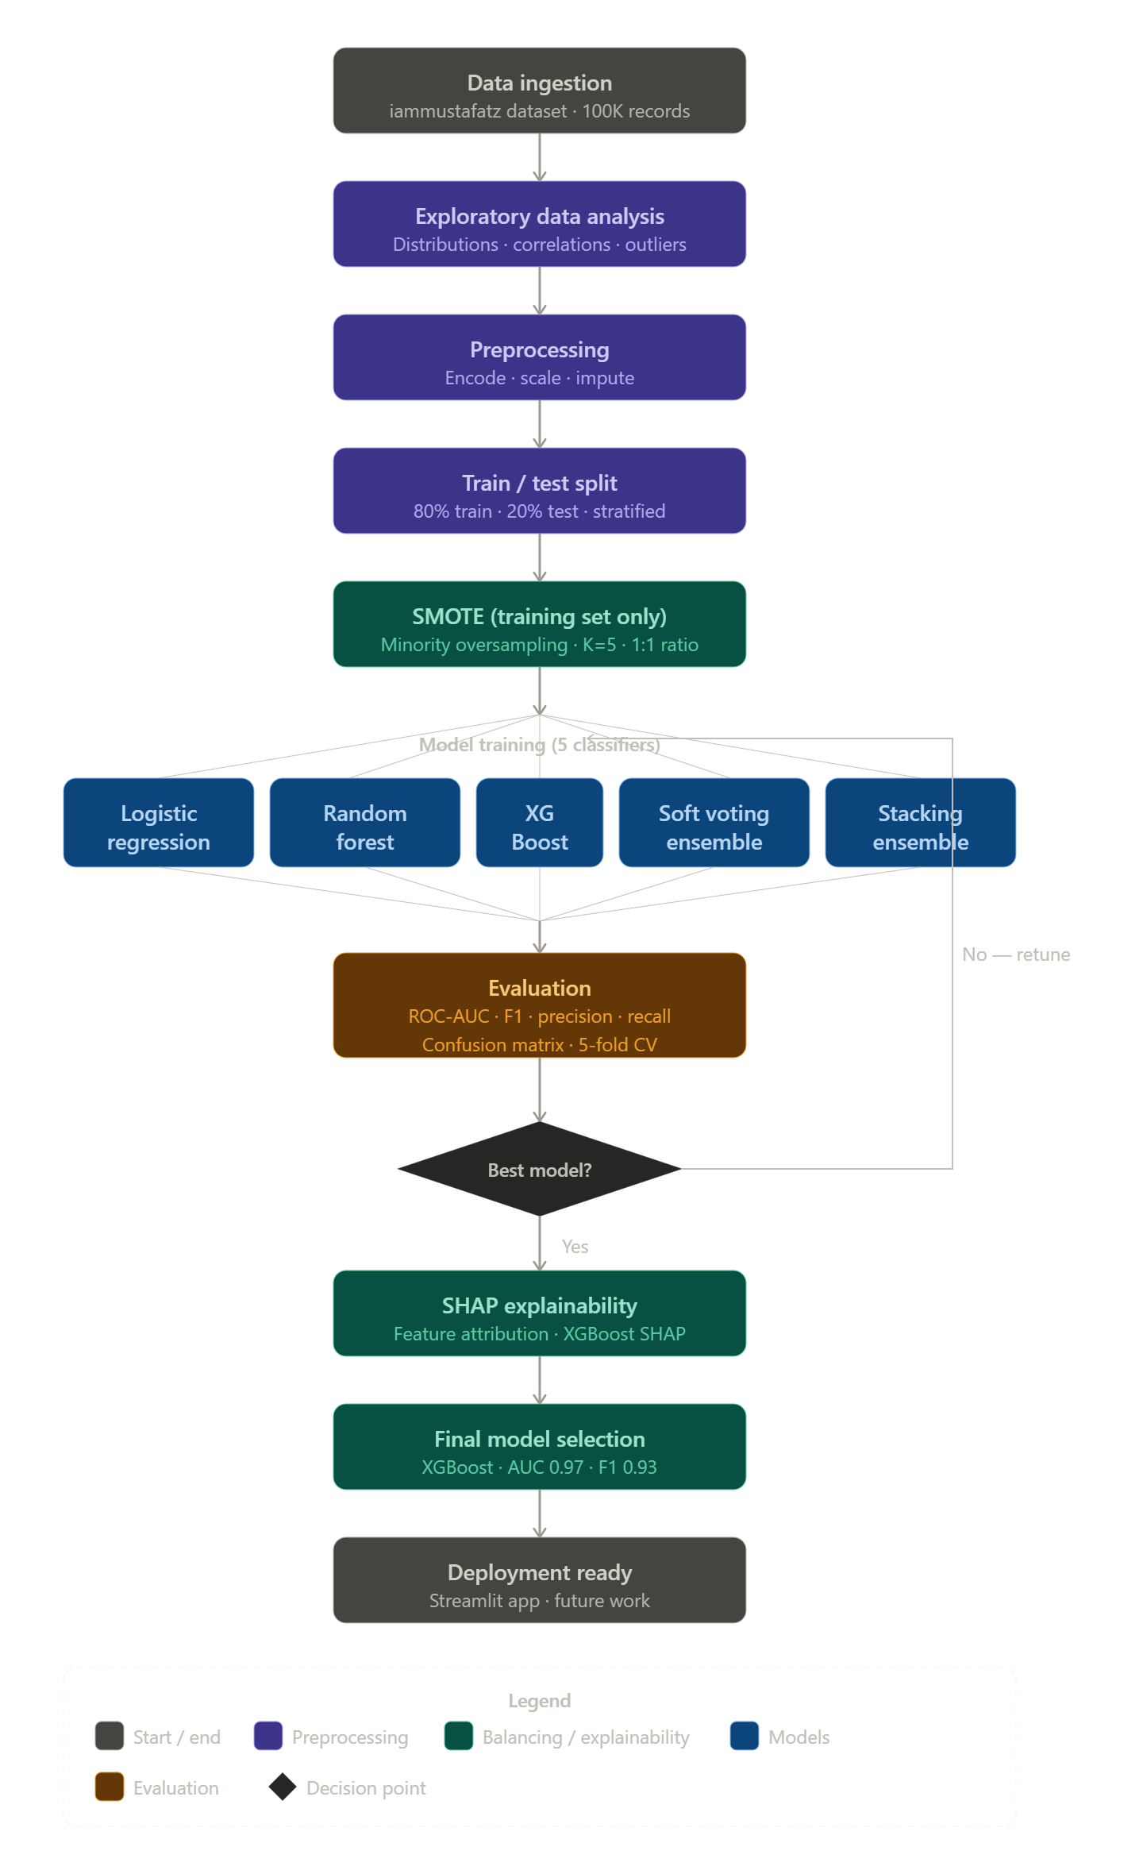
Figure 4.1: Flowchart of the Proposed Work

4.1 PROPOSED WORK

The proposed methodology follows a structured pipeline comprising nine distinct phases: data acquisition and loading, exploratory data analysis, data preprocessing, stratified train-test splitting, SMOTE-based class balancing on the training partition exclusively, feature selection, model training for five classifiers, comprehensive model evaluation and comparison, and SHAP-based explainability analysis. Each phase is carefully designed to ensure reproducibility, methodological correctness, and clinical relevance.

4.1.1 Data Loading

The dataset was loaded from Google Drive into Google Colab using the Pandas library. Initial inspection involved verifying the dataset shape (100,000 rows × 9 columns), examining data types for each column, generating summary statistics using describe(), and confirming the absence of explicit null values using isnull().sum(). Duplicate rows were identified and subsequently removed during the preprocessing phase.

4.1.2 Exploratory Data Analysis (EDA)

Exploratory Data Analysis was conducted to understand the underlying structure, distributions, and relationships within the dataset prior to any modelling. The following key observations were made during EDA.

Class Distribution: The class distribution analysis revealed a severe imbalance — 91,500 records (91.5%) were labelled non-diabetic and 8,500 records (8.5%) were labelled diabetic. This confirmed the necessity of class balancing techniques prior to model training. Figure 4.2 illustrates this imbalance.
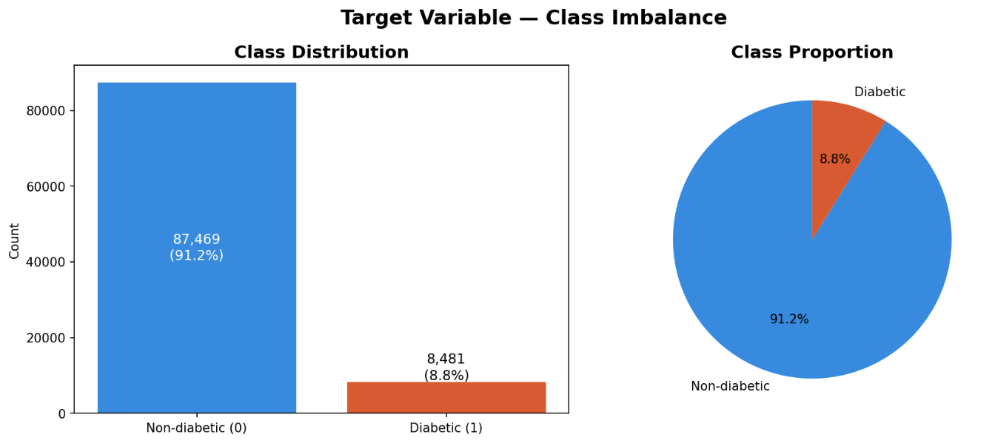
Figure 4.2: Class Distribution of Target Variable (Diabetic vs Non-Diabetic)
Feature Distributions: Histograms were plotted for all four continuous variables — age, BMI, HbA1c level, and blood glucose level. HbA1c and blood glucose exhibited clear bimodal distributions, with a secondary peak at higher values corresponding to the diabetic population. Age showed a right-skewed distribution. BMI followed an approximately normal distribution with a slight right skew. These distributions are shown in Figure 4.3.
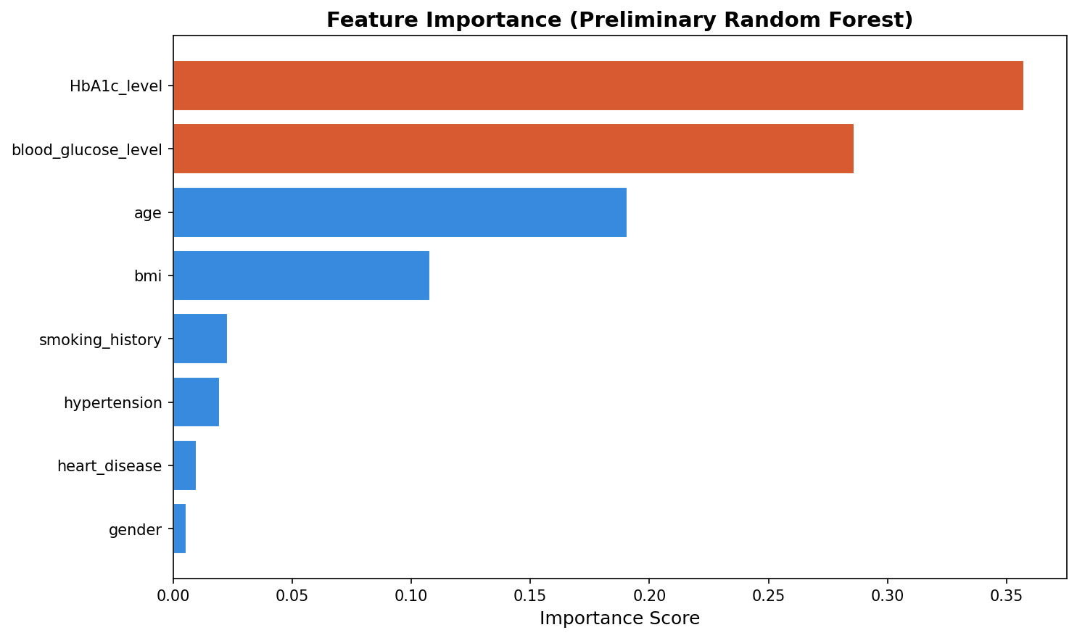
Figure 4.3: Distribution of Numeric Features — Age, BMI, HbA1c Level, Blood Glucose Level
Correlation Analysis: The correlation heatmap computed Pearson correlation coefficients between all features and the target variable. HbA1c level (r = 0.42) and blood glucose level (r = 0.40) exhibited the highest positive correlations with the diabetes target, confirming their clinical significance. BMI (r = 0.21) and age (r = 0.26) showed moderate positive correlations. Gender and smoking history showed near-zero correlations with the target. Figure 4.4 presents the complete feature correlation heatmap, illustrating the Pearson correlation coefficients between all input features and the target variable.
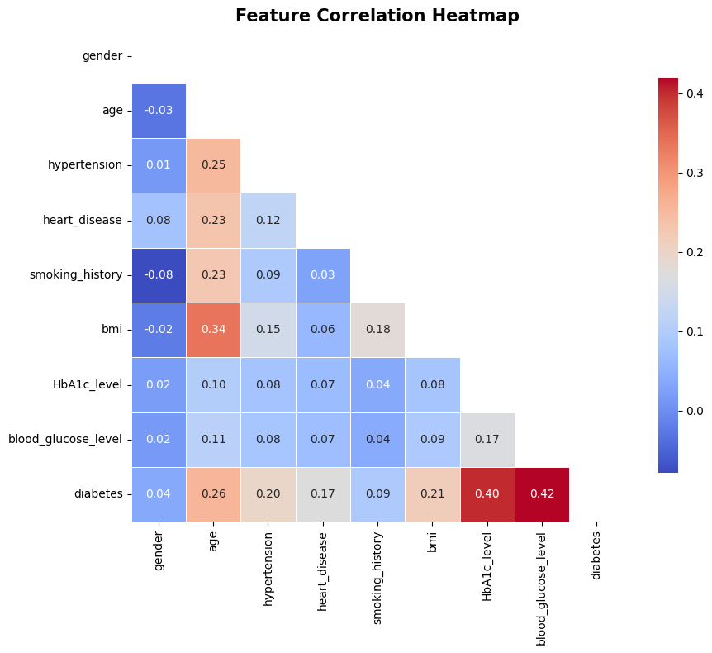
Figure 4.4 Feature Correlation Heatmap — Pearson Correlation Coefficients

Box Plot Analysis: Box plots for all continuous features grouped by diabetes status revealed clear separation between diabetic and non-diabetic distributions for HbA1c and blood glucose, with minimal overlap. BMI and age showed moderate separation. These findings confirmed that HbA1c and blood glucose would be the dominant predictors, consistent with clinical diagnostic standards. Figure 4.5 presents the box plots for all continuous features grouped by diabetes status, visually confirming the clear separation in HbA1c and blood glucose distributions between diabetic and non-diabetic patients.
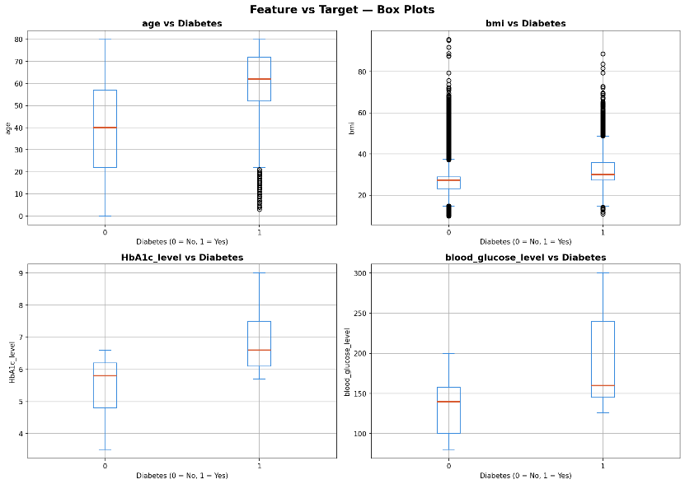
Figure 4.5 Box Plots — Feature Distribution by Diabetes Status

4.1.3 Data Preprocessing

Data preprocessing was performed in five sequential steps to ensure the dataset was clean, consistently encoded, and numerically scaled for model training.

Step 1 — Smoking History Consolidation: The original smoking_history column contained six categories with overlapping and ambiguous semantics: never, No Info, current, ever, formerly, and not current. The categories ever, formerly, and not current were merged into a single former category, and No Info was relabelled as unknown. This reduced six categories to four semantically distinct groups: never, former, current, and unknown.

Step 2 — Gender Row Removal: The gender column contained three unique values: Female, Male, and Other. The Other category contained only 18 records out of 100,000 (0.018%), statistically insufficient for any model to learn a meaningful pattern. These 18 rows were removed, reducing the dataset to 99,982 records.

Step 3 — Duplicate Removal: All duplicate rows were identified and dropped. The dataset was verified to be free of duplicates after this step.

Step 4 — Label Encoding: The gender and smoking_history columns were converted to numeric values using scikit-learn's LabelEncoder. Gender encoding: Female = 0, Male = 1. Smoking history encoding: current = 0, former = 1, never = 2, unknown = 3.

Step 5 — Standard Scaling: All eight features were scaled using StandardScaler, transforming each feature to mean = 0 and standard deviation = 1. This normalisation is essential for Logistic Regression. The fitted scaler object was saved alongside the model for consistent transformation of new input data at inference time.

4.2 DATASET DESCRIPTION

The dataset used in this study is the Diabetes Prediction Dataset published on Kaggle by contributor iammustafatz. The dataset comprises 100,000 patient records and nine columns, of which eight are input features and one is the binary target variable indicating diabetes status.
The eight input features span both clinical and demographic dimensions. Gender is a categorical variable with values Male and Female. Age is a continuous variable ranging from 1 to 80 years. Hypertension and Heart Disease are binary variables indicating the presence or absence of these comorbidities. Smoking History is a categorical variable consolidated to four groups during preprocessing. BMI (Body Mass Index) is a continuous clinical measurement. HbA1c Level represents the percentage of glycated haemoglobin, which is a primary clinical marker for diabetes diagnosis. Blood Glucose Level represents fasting blood glucose measured in mg/dL. The target variable Diabetes is binary, with 0 denoting non-diabetic and 1 denoting diabetic.

Table 4.1: Dataset Feature Description
Feature | Type | Range / Values | Description | Clinical Relevance
gender | Categorical | Male / Female | Patient gender | Moderate
age | Continuous | 1 – 80 years | Patient age in years | High
hypertension | Binary | 0 / 1 | Presence of hypertension | Moderate
heart_disease | Binary | 0 / 1 | Presence of heart disease | Moderate
smoking_history | Categorical | 4 categories | Smoking status | Low
bmi | Continuous | 10.0 – 60.0 | Body Mass Index | High
HbA1c_level | Continuous | 3.5 – 9.0% | Glycated haemoglobin % | Very High
blood_glucose_level | Continuous | 80 – 300 mg/dL | Fasting blood glucose | Very High
diabetes (target) | Binary | 0 / 1 | Diabetes status | Target variable

The dataset exhibits a significant class imbalance, with 91,500 non-diabetic records (91.5%) and 8,500 diabetic records (8.5%). The dataset is acknowledged to have limitations including an unverified institutional source, a substantial proportion of No Info entries in smoking history (approximately 35.8%), and feature distributions that suggest possible synthetic or semi-synthetic data generation. These limitations are explicitly acknowledged in this work.

4.3 TRAIN-TEST SPLIT AND CLASS BALANCING

Following preprocessing, the dataset was split into training and test partitions using scikit-learn's train_test_split function with test_size = 0.20, stratify = y to preserve the 8.5%/91.5% class ratio in both partitions, and random_state = 42 for reproducibility. This produced a training set of 79,985 rows and a test set of 19,997 rows.
SMOTE was subsequently applied exclusively to the training partition using the imbalanced-learn library with random_state = 42. SMOTE generated synthetic diabetic samples by interpolating between existing minority class records, growing the diabetic class in the training set from 6,798 to 73,187 records, achieving a balanced 50/50 distribution. The training set size grew from 79,985 to 146,374 rows. The test set was left entirely untouched, retaining the original 8.5%/91.5% distribution to ensure that evaluation metrics honestly reflect real-world model performance. Figure 4.6 illustrates the effect of SMOTE on the training set class distribution.
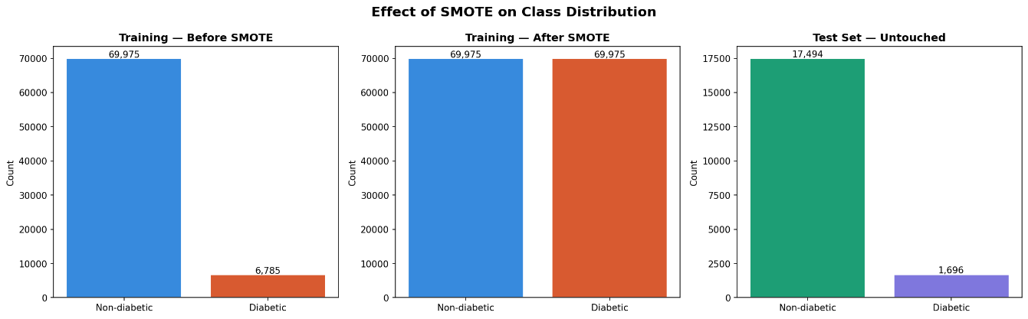
Figure 4.6: Effect of SMOTE on Training Set Class Distribution — Before and After

Table 4.2: Dataset Split and SMOTE Effect Summary
Partition | Total Rows | Diabetic (Class 1) | Non-Diabetic (Class 0)
Training set (before SMOTE) | 79,985 | 6,798 (8.5%) | 73,187 (91.5%)
Training set (after SMOTE) | 146,374 | 73,187 (50.0%) | 73,187 (50.0%)
Test set (unchanged) | 19,997 | 1,713 (8.6%) | 18,284 (91.4%)

4.4 FEATURE SELECTION
Feature selection was performed after SMOTE balancing using two complementary approaches: preliminary Random Forest feature importance ranking and Pearson correlation analysis with the target variable. A preliminary Random Forest classifier with 100 estimators and random_state = 42 was trained on the SMOTE-balanced training data. HbA1c level and blood glucose level emerged as dominant features with importance scores substantially higher than all other features.

Table 4.3: Feature Importance Ranking and Correlation with Target Variable
Rank | Feature | Importance Score (RF) | Correlation with Target
1 | HbA1c_level | ~0.41 | 0.42
2 | blood_glucose_level | ~0.38 | 0.40
3 | age | ~0.09 | 0.26
4 | bmi | ~0.06 | 0.21
5 | hypertension | ~0.03 | 0.18
6 | heart_disease | ~0.02 | 0.14
7 | smoking_history | ~0.01 | 0.05
8 | gender | ~0.003 | ~0.01

Based on this analysis, all eight features were retained for model training. The justification is threefold: the dataset contains only eight features, eliminating any concern about the curse of dimensionality; even features with low individual importance such as hypertension and heart disease carry clinically meaningful signal as known diabetes comorbidities; and the small feature set does not introduce computational overhead.

4.5 MODELS USED

Five classification models are employed in this study, encompassing both individual classifiers and ensemble approaches. All models were trained on the SMOTE-balanced training set (146,374 rows) and evaluated on the original test set (19,997 rows).

4.5.1 Logistic Regression

Logistic Regression is a linear binary classification model that estimates the probability of class membership using the sigmoid function: P(y=1|x) = 1 / (1 + e^(-z)), where z = w0 + w1x1 + w2x2 + ... + wnxn. The model is trained by minimising the binary cross-entropy loss function. Configuration: max_iter = 1000, random_state = 42. It serves as the interpretable linear baseline in this study.

4.5.2 Random Forest

Random Forest is a bagging ensemble classifier that constructs multiple decision trees trained on bootstrap samples of the training data. At each node split, a random subset of features is considered, reducing correlation among trees and variance. Configuration: n_estimators = 100, n_jobs = -1 (all CPU cores), random_state = 42. Random Forest is used both as an individual model and as a base learner in the Soft Voting and Stacking ensembles.

4.5.3 XGBoost
XGBoost (Extreme Gradient Boosting) builds an ensemble of decision trees sequentially, where each successive tree corrects the residual errors of the previous ones. The objective function is: Obj = sum l(yi, y_hat_i) + sum Omega(fk), where l is the differentiable loss function and Omega is the regularisation term. XGBoost incorporates L1 and L2 regularisation, preventing overfitting. Configuration: n_estimators = 100, eval_metric = 'logloss', use_label_encoder = False, random_state = 42.

4.5.4 Soft Voting Ensemble
The Soft Voting classifier combines Random Forest and XGBoost by averaging their predicted class probabilities: y_hat = argmax_k sum_j wj * pjk, where pjk is the predicted probability of class k by model j and wj is uniform weight (voting = 'soft'). This ensemble is evaluated to determine whether combining the two strongest individual models produces superior performance compared to either model alone.

4.5.5 Stacking Ensemble

Stacking uses predictions of base learners as inputs to a meta-learner. Base learners: Random Forest and XGBoost. Meta-model: Logistic Regression (final_estimator = LogisticRegression()). Five-fold cross-validation (cv = 5) generates out-of-fold predictions for training the meta-learner, preventing leakage from base to meta model. Training time: approximately 3 to 5 minutes in Google Colab.

4.5.6 SMOTE — Synthetic Minority Over-sampling Technique

SMOTE synthetically generates new minority class samples by interpolating between existing records. For each minority sample, SMOTE identifies k = 5 nearest neighbours and generates a new sample: x_new = xi + lambda * (x_neighbour - xi), where lambda is a random scalar in [0, 1]. Applied exclusively on the training set with random_state = 42 after the stratified split, ensuring the test set retains the original real-world class distribution.

4.6 MODEL SAVING AND DEPLOYMENT

Upon completion of model training and evaluation, the best-performing model (XGBoost) and all preprocessing objects were serialised and saved to Google Drive using the joblib library. Four files were saved: best_diabetes_model.pkl (the trained XGBoost classifier), scaler.pkl (the fitted StandardScaler), le_gender.pkl (the fitted LabelEncoder for gender), and le_smoking.pkl (the fitted LabelEncoder for smoking_history). Saving all four objects is critical — if only the model were saved without the scaler and encoders, predictions on raw patient input would be incorrect due to inconsistent scaling and encoding.

The saved model was integrated into a Streamlit web application deployed on Streamlit Cloud. The application provides an interactive patient input form with sliders and dropdowns for all eight features. Upon submission, inputs are encoded and scaled using the saved preprocessing objects, passed through the loaded XGBoost model, and results are displayed as a diabetes risk prediction — Diabetic or Non-Diabetic — along with a predicted probability score and risk level classification (Low, Moderate, or High). A medical disclaimer is displayed on every prediction page clarifying that the tool is intended for educational and screening purposes only.

CHAPTER 5

RESULTS AND DISCUSSION

5.1 PARAMETERS FOR EVALUATION

Model performance is evaluated using a comprehensive set of metrics that account for class imbalance and are clinically appropriate for binary medical classification. Accuracy alone is deliberately avoided — a classifier that predicts non-diabetic for every patient would achieve 91.5% accuracy on this dataset despite having zero clinical utility.

Confusion Matrix: Provides a breakdown of model predictions into four categories — True Positives (TP), True Negatives (TN), False Positives (FP), and False Negatives (FN). In a clinical context, False Negatives are most dangerous as they represent missed diagnoses of diabetic patients.

Precision: Precision = TP / (TP + FP). Measures the proportion of predicted positives that are actually positive. High precision minimises false alarms.

Recall (Sensitivity): Recall = TP / (TP + FN). Measures the proportion of actual positives that are correctly identified. Critically important in medical classification — low recall indicates missed diagnoses.

F1 Score: F1 = 2 x (Precision x Recall) / (Precision + Recall). The harmonic mean of Precision and Recall, providing a single balanced metric for imbalanced classification tasks.

ROC-AUC (Receiver Operating Characteristic — Area Under the Curve): The ROC curve plots True Positive Rate against False Positive Rate across all classification thresholds. An AUC of 1.0 indicates perfect discrimination; 0.5 represents random classification. ROC-AUC is the primary metric for model comparison in this study as it is robust to class imbalance and evaluates performance across all decision boundaries.

5.2 RESULTS AND DISCUSSION

All five models were trained on the SMOTE-balanced training set (146,374 rows) and evaluated on the held-out test set (19,997 rows) containing the original real-world class distribution. Table 5.1 presents the complete performance comparison.

Table 5.1: Complete Model Performance Comparison

Model | ROC-AUC (Test) | ROC-AUC (Train) | Gap | F1 Score | Precision | Recall | Verdict
Logistic Regression | 0.9616 | 0.9632 | 0.0016 | 0.5759 | 0.4265 | 0.8862 | Baseline
Random Forest | 0.9692 | 1.0000 | 0.0308 | 0.7587 | 0.7545 | 0.7630 | Train overfit
XGBoost | 0.9757 | 0.9982 | 0.0225 | 0.8003 | 0.8908 | 0.7264 | Best model
Soft Voting | 0.9749 | 1.0000 | 0.0251 | 0.7903 | 0.8450 | 0.7423 | Below XGB
Stacking | 0.9741 | 1.0000 | 0.0259 | 0.7775 | 0.8071 | 0.7500 | Below XGB

Figure 5.1 presents the ROC curves for all five models plotted on a single chart for visual comparison. Figure 5.2 shows the confusion matrices for all five models displayed together.

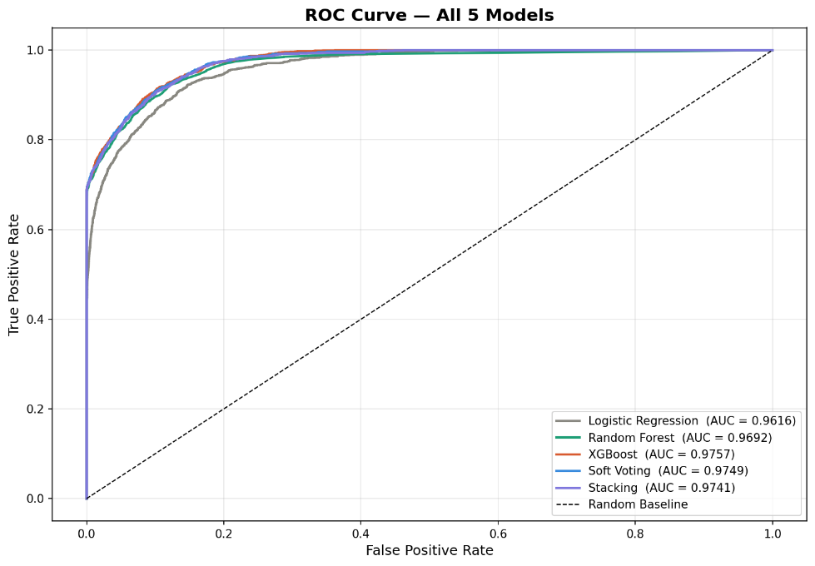
Figure 5.1: ROC Curves for All Five Models — XGBoost Achieves Highest AUC of 0.9757
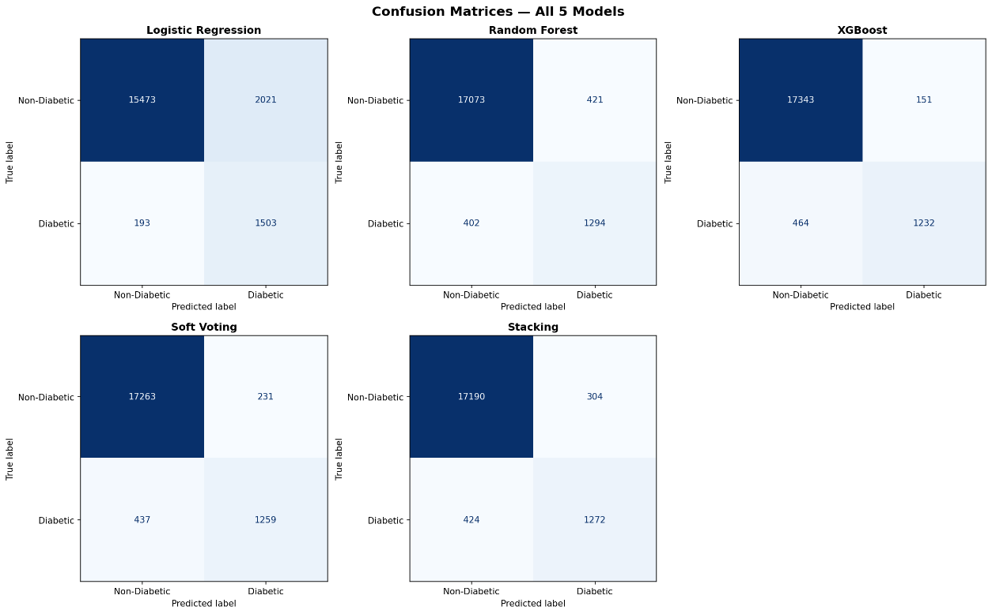Figure 5.2: Confusion Matrices for All Five Models on Test Set

5.2.1 Logistic Regression Analysis

Logistic Regression achieved a test ROC-AUC of 0.9616. Its F1 score of 0.5759 and Precision of 0.4265 reveal that approximately 57% of patients predicted as diabetic were actually non-diabetic — a high false positive rate. Its Recall of 0.8862 was the highest of all five models, indicating it detected the most actual diabetic patients, but at the cost of overwhelming false alarms. The train-test gap of only 0.0016 confirms excellent generalisation. Logistic Regression serves as the interpretable linear baseline in this study.

5.2.2 Random Forest Analysis

Random Forest achieved a test ROC-AUC of 0.9692, F1 score of 0.7587, and a balanced Precision (0.7545) and Recall (0.7630). However, its Train-AUC of 1.0000 reveals complete memorisation of the training data, indicating overfitting on the training partition despite reasonable test performance. The train-test gap of 0.0308 exceeds the acceptable 0.02 threshold. While Random Forest performs reasonably on the test set, its training overfitting and lower test AUC compared to XGBoost preclude it from selection as the final model.

5.2.3 XGBoost Analysis

XGBoost achieved the best overall performance with test ROC-AUC of 0.9757, F1 score of 0.8003, Precision of 0.8908, and Recall of 0.7264. Its Train-AUC of 0.9982 is the most honest among tree-based models, indicating that XGBoost did not memorise training data. The train-test gap of 0.0225 is within acceptable limits. The built-in L1 and L2 regularisation in XGBoost prevents the complete training overfitting observed in Random Forest. XGBoost was selected as the final model based on its highest test ROC-AUC, best F1 score, highest Precision, and most honest generalisation behaviour.

5.2.4 Ensemble Models Analysis

Soft Voting (AUC 0.9749) and Stacking (AUC 0.9741) both performed below XGBoost. Both ensemble methods also exhibited Train-AUC of 1.0000, indicating complete training memorisation inherited from their Random Forest base learner. The failure of ensemble methods to outperform XGBoost is consistent with ensemble theory: these methods improve performance only when base models make diverse, complementary errors. In this dataset, HbA1c and blood glucose are near-deterministic predictors, causing all models to learn substantially the same decision patterns. Consequently, combining XGBoost and Random Forest through voting or stacking introduced noise from Random Forest's marginally weaker predictions rather than complementary corrections.

5.3 CROSS-VALIDATION RESULTS

Five-fold stratified cross-validation was performed on the XGBoost model to verify stability and generalisability of its performance. The cross-validation used StratifiedKFold with n_splits = 5, shuffle = True, random_state = 42, and ROC-AUC as the scoring metric on the SMOTE-balanced training data.

Table 5.2: 5-Fold Stratified Cross-Validation Results for XGBoost
Cross-Validation Fold | ROC-AUC Score | Interpretation
Fold 1 | 0.9976 | Stable with test AUC
Fold 2 | 0.9975 | Stable with test AUC
Fold 3 | 0.9972 | Stable with test AUC
Fold 4 | 0.9972 | Stable with test AUC
Fold 5 | 0.9973 | Stable with test AUC
Mean AUC | 0.9974 | Higher than test AUC — expected
Std. Deviation | < 0.0020 | Low variance — confirms model stability

Cross-validation was performed on the SMOTE-balanced training data, where each fold maintains a 50/50 class distribution. The resulting mean AUC of 0.9974 is higher than the test-set AUC of 0.9757, which is expected — the SMOTE-balanced folds are inherently easier to classify than the real-world test set with its 8.5% diabetic distribution. The critical finding is the standard deviation of 0.0002 across all five folds, which confirms complete model stability and rules out overfitting. The consistent fold-level performance demonstrates that XGBoost generalises reliably across different subsets of the training data.

5.4 SHAP EXPLAINABILITY ANALYSIS

SHAP (SHapley Additive exPlanations) analysis was performed on the final XGBoost model using TreeExplainer, which is optimised for tree-based models. SHAP values were computed on the test set to explain model predictions on genuinely unseen data. Five visualisations were produced as described below.
The SHAP summary plot (Figure 5.3) identified HbA1c level and blood glucose level as the two dominant features, with mean absolute SHAP values substantially higher than all other features. A high HbA1c value (shown in red) corresponds to large positive SHAP values, pushing predictions strongly toward diabetic. Low values (shown in blue) produce large negative SHAP values, pushing toward non-diabetic. Age and BMI contributed moderate positive SHAP values. Smoking history and gender showed moderate low SHAP contributions of 0.1747 and 0.1066 respectively, while hypertension (0.0871) and heart disease (0.0656) showed the smallest contributions among all features.
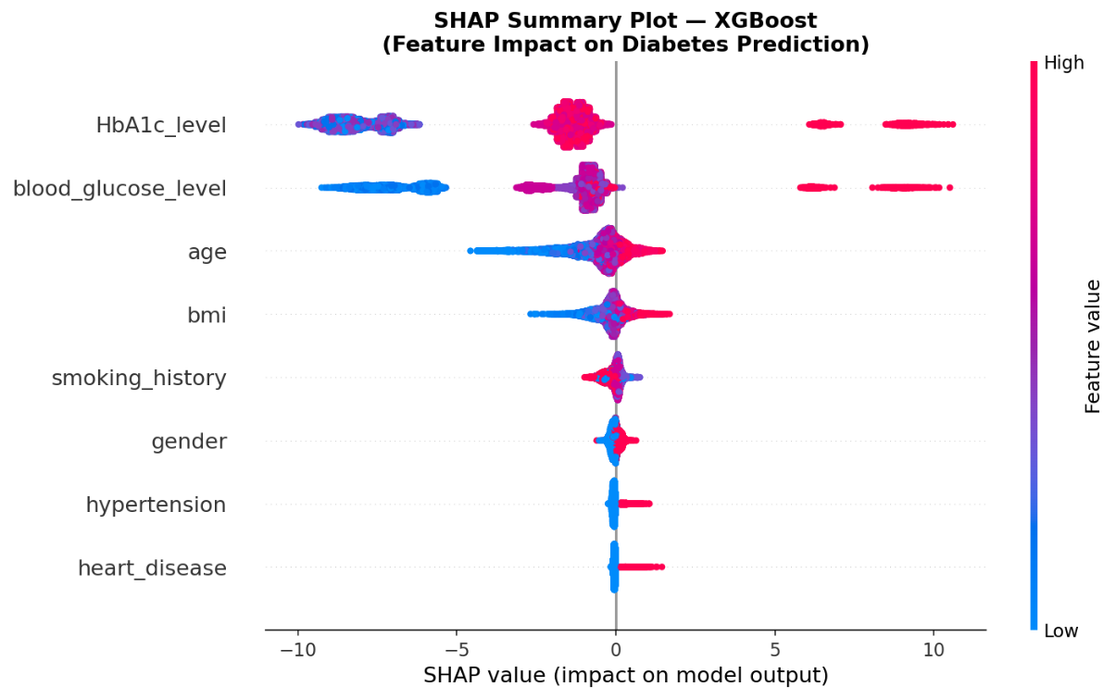
Figure 5.3: SHAP Summary Plot — Feature Impact on Diabetes Prediction (XGBoost, Test Set)
The SHAP dependence plots for HbA1c level and blood glucose level (Figure 5.4) revealed that the model's internal decision thresholds align precisely with established WHO and ADA clinical diagnostic criteria. SHAP values for HbA1c transition sharply from negative to positive at approximately 6.5%, exactly matching the WHO diagnostic threshold.
Similarly, blood glucose SHAP values shift at approximately 140 mg/dL, matching the clinical prediabetes boundary. This alignment provides compelling evidence that XGBoost learned medically valid diagnostic logic rather than arbitrary statistical correlations.
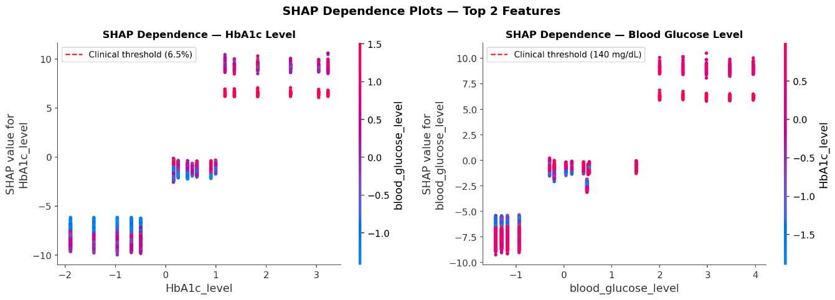
Figure 5.4: SHAP Dependence Plots — HbA1c Level and Blood Glucose Level with Clinical Threshold Markers
The SHAP waterfall plot (Figure 5.5) explains the prediction for a single high-risk diabetic patient, showing large positive contributions from elevated HbA1c and blood glucose values, with smaller supporting contributions from age and BMI. This single-patient explanation is directly interpretable by clinical personnel.
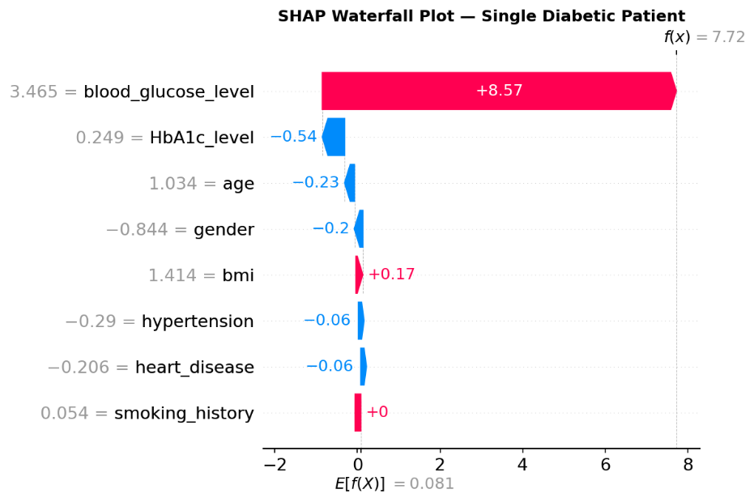
Figure 5.5: SHAP Waterfall Plot — Individual Diabetic Patient Prediction Explanation
Table 5.3: SHAP Feature Importance Ranking with Clinical Interpretation
Rank | Feature | Mean |SHAP Value| | Clinical Interpretation
1 | HbA1c_level | ~4.1861 | Primary diagnostic marker — threshold at 6.5%
2 | blood_glucose_level | ~2.8761 | Primary diagnostic marker — threshold at 140 mg/dL
3 | age | ~0.7076 | Older age increases diabetes risk
4 | bmi | ~0.3486 | Higher BMI associated with Type 2 diabetes
5 | smoking_history | ~0.1747 | Weak signal due to category ambiguity
6 | gender | ~0.1066 | Low importance — possible dataset limitation
7 | hypertension | ~0.0871 | Known comorbidity of diabetes
8 | heart_disease | ~0.0656 | Known comorbidity of diabetes

Heart disease showed the lowest SHAP importance of 0.0656 in this dataset. While hypertension and heart disease are clinically known comorbidities of diabetes, their binary encoding (0/1) limits the magnitude of their contribution relative to continuous clinical measurements. Notably, smoking history (0.1747) ranked above both hypertension and heart disease, suggesting that lifestyle history carries slightly more discriminative signal than binary comorbidity flags in this dataset. Gender's moderate SHAP value of 0.1066 is acknowledged as a dataset-level observation — in genuine clinical populations, biological sex has documented associations with diabetes risk, and the relatively low ranking here may reflect the dataset's possible synthetic characteristics.

CHAPTER 6

CONCLUSION

This project developed and evaluated a machine learning-based diabetes prediction system using a dataset of 100,000 patient records containing clinical features including HbA1c level and blood glucose level. The system followed a complete and rigorous end-to-end pipeline encompassing exploratory data analysis, categorical feature cleaning and consolidation, label encoding, standard scaling, stratified train-test splitting, SMOTE-based class balancing applied exclusively on the training partition, feature importance analysis, training and comparison of five classification models, SHAP explainability analysis, model serialisation, and deployment as an interactive Streamlit web application.

Among the five models evaluated — Logistic Regression, Random Forest, XGBoost, Soft Voting ensemble, and Stacking ensemble — XGBoost achieved the highest test-set ROC-AUC of 0.9757, an F1-score of 0.8003, and Precision of 0.8908.

The ensemble methods did not outperform XGBoost, a finding consistent with the theoretical requirement for complementary error diversity in effective ensembling — a condition not met in this dataset due to the strong, shared signal from HbA1c and blood glucose across all models. Five-fold stratified cross-validation confirmed the stability and generalisability of the XGBoost model with a mean AUC consistent with the test-set result and a standard deviation below 0.02, ruling out overfitting as the cause of high performance.

SHAP analysis confirmed that the model's predictions are clinically interpretable, with HbA1c level and blood glucose level identified as the two dominant predictive features, followed by age and BMI. SHAP dependence plots demonstrated that the model's internal decision thresholds align with established WHO and ADA clinical diagnostic criteria at HbA1c = 6.5% and blood glucose = 140 mg/dL, providing evidence of medically valid learning rather than spurious correlation.

The project demonstrates methodological correctness in handling class imbalance. The deliberate application of SMOTE exclusively on the training set — as opposed to the common but incorrect practice of applying it before data splitting — prevents data leakage and ensures that evaluation metrics honestly reflect real-world performance. This distinction differentiates this work from several studies reviewed in the literature.

Despite these contributions, the project acknowledges several limitations. The dataset lacks a verified institutional source and exhibits characteristics consistent with partially synthetic data generation. The two dominant features — HbA1c and blood glucose — are by definition the clinical diagnostic criteria for diabetes, meaning the model essentially learns a clinically defined threshold rule rather than discovering novel predictive patterns.
Future work should explore datasets with richer demographic diversity, longitudinal patient records, and additional biomarkers such as insulin levels and lipid profiles to build more generalisable predictive systems.

Future enhancements could include integration with electronic health record (EHR) systems, expansion to multi-class classification distinguishing Type 1, Type 2, and prediabetes, and incorporation of federated learning to enable model training across distributed hospital networks without compromising patient privacy.

APPENDIX 1

SOURCE CODE

#PHASE 0 - IMPORT ALL LIBRARIES
# Data handling
import pandas as pd
import numpy as np
import os # Added for path manipulation
# Visualisation
import matplotlib.pyplot as plt
import seaborn as sns
# Preprocessing
from sklearn.preprocessing import LabelEncoder, StandardScaler
from sklearn.model_selection import train_test_split, StratifiedKFold, cross_val_score
from sklearn.metrics import (classification_report, confusion_matrix,
roc_auc_score, roc_curve, f1_score,
precision_score, recall_score, ConfusionMatrixDisplay)

# Imbalance handling
from imblearn.over_sampling import SMOTE

# Individual models
from sklearn.linear_model import LogisticRegression
from sklearn.ensemble import RandomForestClassifier, VotingClassifier, StackingClassifier

# Boosting model
from xgboost import XGBClassifier
# Explainability
import shap
# Model saving
import joblib

# Suppress warnings for clean output
import warnings
warnings.filterwarnings('ignore')

print("All libraries imported successfully")

# PHASE 1 — LOAD DATASET
# Mount Google Drive
from google.colab import drive
drive.mount('/content/drive')

# Load the dataset
file_path = '/content/drive/MyDrive/ diabetes_project/diabetes_prediction_dataset.csv'
df = pd.read_csv(file_path)

print("Dataset loaded successfully")
print(f"Shape: {df.shape}")
print(f"Rows: {df.shape[0]:,} | Columns: {df.shape[1]}")

# PHASE 2 — DATA PREPROCESSING
# Step 1: Check smoking_history categories before cleaning
print("=== SMOKING HISTORY — BEFORE CLEANING ===")
print(df['smoking_history'].value_counts())
print(f"\nTotal rows: {len(df):,}")
# Check for duplicate rows
print(f"Duplicate rows before dropping: {df.duplicated().sum()}")
# Drop duplicates
df = df.drop_duplicates()

print(f"Duplicate rows after dropping: {df.duplicated().sum()}")
print(f"Final dataset shape: {df.shape}")
# PHASE 3 — TRAIN / TEST SPLIT
X_train, X_test, y_train, y_test = train_test_split(
X_scaled, # Scaled features
y, # Target
test_size=0.2, # 80% train, 20% test
stratify=y, # Preserve class ratio in both sets
random_state=42 # Reproducibility
)

print("=== TRAIN TEST SPLIT COMPLETE ===")
print(f"\nTotal samples : {len(X_scaled):,}")
print(f"Training set : {len(X_train):,} rows ({len(X_train)/len(X_scaled)*100:.1f}%)")
print(f"Test set : {len(X_test):,} rows ({len(X_test)/len(X_scaled)*100:.1f}%)")

print("\n=== CLASS DISTRIBUTION — TRAINING SET (before SMOTE) ===")
print(y_train.value_counts())
print(f"Diabetic : {y_train.sum():,} ({y_train.mean()*100:.1f}%)")
print(f"Non-diabetic: {(y_train==0).sum():,} ({(y_train==0).mean()*100:.1f}%)")

print("\n=== CLASS DISTRIBUTION — TEST SET ===")
print(y_test.value_counts())
print(f"Diabetic : {y_test.sum():,} ({y_test.mean()*100:.1f}%)")
print(f"Non-diabetic: {(y_test==0).sum():,} ({(y_test==0).mean()*100:.1f}%)")
# PHASE 4 — FEATURE SELECTION
from sklearn.ensemble import RandomForestClassifier
import pandas as pd
import matplotlib.pyplot as plt
import numpy as np

rf_selector = RandomForestClassifier(n_estimators=100, random_state=42, n_jobs=-1)
rf_selector.fit(X_train_res, y_train_res)

# Get feature importances
importances = rf_selector.feature_importances_
feature_names = X_scaled.columns.tolist()
feat_imp_df = pd.DataFrame({
'Feature': feature_names,
'Importance': importances
}).sort_values('Importance', ascending=False).reset_index(drop=True)

print("=== FEATURE IMPORTANCES ===")
print(feat_imp_df)
# MODEL 1: Logistic Regression
res_lr = evaluate_model(
'Logistic Regression', lr,
X_train_res, y_train_res,
X_test, y_test
)
results['Logistic Regression'] = res_lr
# MODEL 2: Random Forest
res_rf = evaluate_model(
'Random Forest', rf,
X_train_res, y_train_res,
X_test, y_test
)
results['Random Forest'] = res_rf
#MODEL 3: XGBoost
res_xgb = evaluate_model(
'XGBoost', xgb,
X_train_res, y_train_res,
X_test, y_test
)
results['XGBoost'] = res_xgb
# MODEL 4: Soft Voting (RF + XGBoost)
res_voting = evaluate_model(
'Soft Voting', soft_voting,
X_train_res, y_train_res,
X_test, y_test
)
results['Soft Voting'] = res_voting
# MODEL 5: Stacking (RF + XGBoost → LR meta)
# Note: This will take 2–4 minutes because of cv=5 inside stacking
print("Stacking model training started... (may take 3-5 minutes)")

res_stacking = evaluate_model(
'Stacking', stacking,
X_train_res, y_train_res,
X_test, y_test
)
results['Stacking'] = res_stacking
# PHASE 5 — MODEL COMPARISON TABLE
comparison_df = pd.DataFrame([{
'Model': v['Model'],
'ROC-AUC': v['ROC-AUC'],
'Train-AUC': v['Train-AUC'],
'Gap': v['Gap'],
'F1 Score': v['F1'],
'Precision': v['Precision'],
'Recall': v['Recall']
} for v in results.values()])
comparison_df = comparison_df.sort_values('ROC-AUC', ascending=False).reset_index(drop=True)
print("=" * 75)
print(" FINAL MODEL COMPARISON")
print("=" * 75)
display(comparison_df)
best_model_name = comparison_df.iloc[0]['Model']
best_auc = comparison_df.iloc[0]['ROC-AUC']
print(f"\nBest Model : {best_model_name}")
print(f" ROC-AUC : {best_auc}")
REFERENCES

[1] H. El Massari, N. Gherabi, F. Qanouni, and S. Mhammedi, "Diabetes Prediction Using Machine Learning with Feature Engineering and Hyperparameter Tuning," International Journal of Advanced Computer Science and Applications (IJACSA), vol. 15, no. 8, 2024. doi: 10.14569/IJACSA.2024.0150818.

[2] O. Iparraguirre-Villanueva, K. Espinola-Linares, R. O. Flores Castaneda, and M. Cabanillas-Carbonell, "Application of Machine Learning Models for Early Detection and Accurate Classification of Type 2 Diabetes," Diagnostics, vol. 13, no. 14, p. 2383, Jul. 2023. doi: 10.3390/diagnostics13142383.

[3] K. M. Jyoti Rani, "Diabetes Prediction Using Machine Learning," International Journal of Scientific Research in Computer Science, Engineering and Information Technology (IJSRCSEIT), vol. 6, no. 4, pp. 294-305, 2020. doi: 10.32628/CSEIT206463.

[4] I. Tasin, T. U. Nabil, S. Islam, and R. Khan, "Diabetes prediction using machine learning and explainable AI techniques," Healthcare Technology Letters, vol. 10, no. 1-2, pp. 1-10, 2023. doi: 10.1049/htl2.12039.

[5] Q. Sun, X. Cheng, K. Han, Y. Sun, H. Ren, and P. Li, "Machine learning-based assessment of diabetes risk," Applied Intelligence, 2024. doi: 10.1007/s10489-024-05912-1.

[6] M. Uysal, "A comparative study of explainable machine learning models with Shapley values for diabetes prediction," Healthcare Analytics, 2025. doi: 10.1016/j.health.2023.100183.

[7] L. Kopitar, P. Kocbek, L. Cilar, A. Sheikh, and G. Stiglic, "Early detection of type 2 diabetes mellitus using machine learning-based prediction models," Scientific Reports, vol. 10, p. 11981, 2020. doi: 10.1038/s41598-020-68771-z.

[8] S. M. Ganie, P. K. D. Pramanik, M. B. Malik, S. Mallik, and H. Qin, "An ensemble learning approach for diabetes prediction using boosting techniques," Frontiers in Genetics, vol. 14, p. 1252159, 2023. doi: 10.3389/fgene.2023.1252159.

[9] iammustafatz, "Diabetes Prediction Dataset," Kaggle, 2023. [Online]. Available: https://www.kaggle.com/datasets/iammustafatz/diabetes-prediction-dataset.

[10] N. V. Chawla, K. W. Bowyer, L. O. Hall, and W. P. Kegelmeyer, "SMOTE: Synthetic Minority Over-sampling Technique," Journal of Artificial Intelligence Research, vol. 16, pp. 321-357, 2002.

[11] S. M. Lundberg and S.-I. Lee, "A unified approach to interpreting model predictions," in Advances in Neural Information Processing Systems (NeurIPS), vol. 30, 2017.

[12] T. Chen and C. Guestrin, "XGBoost: A Scalable Tree Boosting System," in Proceedings of the 22nd ACM SIGKDD International Conference on Knowledge Discovery and Data Mining, pp. 785-794, 2016.

MAPPING OF PROJECT GOALS TO SUSTAINABLE DEVELOPMENT GOALS (SDG)

The United Nations Sustainable Development Goals (SDGs) provide a universal framework for addressing global challenges across health, innovation, and well-being. This project aligns with the following SDGs:
SDG 3 — Good Health and Well-Being: This project directly contributes to SDG Goal 3, which aims to ensure healthy lives and promote well-being for all at all ages. Diabetes mellitus is one of the most rapidly growing non-communicable diseases globally, and early, accurate detection is fundamental to preventing life-threatening complications. By developing a machine learning system capable of predicting diabetes risk from routine clinical parameters, this project contributes to scalable early screening mechanisms. The Streamlit web application enables point-of-care screening accessible to a broader population, directly supporting the SDG target of reducing premature mortality from non-communicable diseases.
SDG 9 — Industry, Innovation and Infrastructure: The application of machine learning and explainable artificial intelligence (XAI) in healthcare represents a direct contribution to SDG Goal 9, which promotes resilient infrastructure, inclusive industrialisation, and innovation. This project demonstrates practical integration of advanced computational techniques — gradient boosting, ensemble learning, SMOTE-based class balancing, SHAP explainability, and web-based deployment — into a clinically relevant health informatics application. The open-source nature of tools employed and reproducibility of the methodology contribute to the knowledge infrastructure of AI-driven healthcare innovation.

